The thief has found himself a new place for his thievery again. There is only one entrance to this area, called root.

Besides the root, each house has one and only one parent house. After a tour, the smart thief realized that all houses in this place form a binary tree. It will automatically contact the police if **two directly-linked houses were broken into on the same night**.

Given the root of the binary tree, return *the maximum amount of money the thief can rob****without alerting the police***.

**Example 1:**

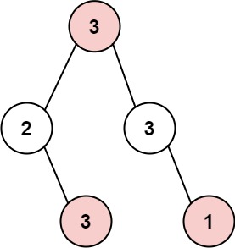

**Input:** root = [3,2,3,null,3,null,1]

**Output:** 7

**Explanation:** Maximum amount of money the thief can rob = 3 + 3 + 1 = 7.

**Example 2:**

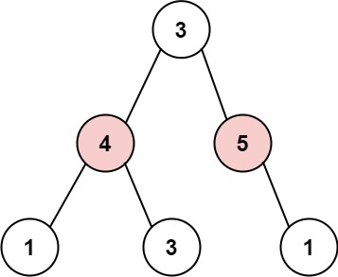

**Input:** root = [3,4,5,1,3,null,1]

**Output:** 9

**Explanation:** Maximum amount of money the thief can rob = 4 + 5 = 9.

**Constraints:**

* The number of nodes in the tree is in the range [1, 104].
* 0 <= Node.val <= 104